2022 VGCI Convention Registration Form
September 29, 30, and October 1, 2022
www.vaselineglass.org

The 23rd Annual VGCI Convention will be held in Miamisburg, Ohio (near Dayton), September 29, 30, and October 1, 2022. The site of the convention will be the Hilton Garden Inn Dayton South/Austin Landing, 12000 Innovation Drive, Miamisburg, Ohio, 45342. Hotel reservations can be made by calling the hotel directly at 937-247-5850 and using the group code VGC to get our discounted room rate of $129 for a double or king room. This rate includes up to two hot breakfasts each morning, including shoulder dates. We have also reserved a couple of king suites at a cost of $169 if you need extra room. These room rates will be honored September 26-October 3. Make your reservation as soon as possible but definitely by September 14, 2022, the last date these rates are guaranteed. If you have any questions or problems, please contact Bob Harry at 407-933-7468 or Nancy Tompkins at 814-880-5232.

For Reservation Purposes: If you are planning to attend the optional tour, you will want to arrive in Miamisburg on Wednesday, September 28, 2022, as the bus will be leaving early on Thursday morning. As to checking out, please plan to check out on Sunday as we will be having a dinner and speaker on Saturday evening.

For the safety of everyone, we will be observing all COVID-19 precaution guidelines in effect during convention and at all events and gatherings. The safety of our members is foremost in how we will conduct all activities.

Displays: There will be $100 awards for displays again this year for Best Single Piece, Best Theme, Most Educational, and Best Visual. Each category will receive an award. Please consider setting up a display. We have plenty of room and everyone wants to see your favorite pieces!

Swap & Shop: One of the best chances you will get to buy or sell glass, Swap & Shop is also a great way to meet fellow VGCI members and perhaps find a piece for your collection that you may not find anywhere else. Swap & Shop is conducted from room-to-room. Participating rooms may list their room number on the easel at our registration table.

Meals: Meals will be provided as follows: Each room reserved will receive up to two hot breakfasts per day. This includes shoulder dates. Included in your registration fee are three evening meals, one each Thursday (opening reception), Friday and Saturday. The times for each meal will be printed in your Welcome Packet that you will receive upon hotel arrival. There is no discount on convention fees if you decide not to participate in any or all of the meals.

Optional Tour: Plan to join us for a fabulous optional motor coach trip that includes three museum stops as follows: Greentown Glass Museum, Greentown, Indiana, Albany Glass Museum, Albany, Indiana, and the Dunkirk Glass Museum, Dunkirk, Indiana. This optional trip will be available on a first come-first served basis. There will be an on-your-own lunch stop at Panera.

Mound Cold War Discovery Center: VGCI Club Member, Robert Bowman, Jr., PhD, has offered to conduct a tour of the Mound Cold War Discovery Center where you will see exhibits on radioactive materials (including uranium glass) and their applications. Dr. Bowman is a museum board member as well as a docent. The MCWDC is about 10 minutes away from our hotel convention site. Travel to the museum will be on your own and you will need to take your own vehicle or arrange to carpool. There is no cost for this tour and the museum does not charge any admission, although appreciates donations. Date and time yet to be determined. You can read about it here: https://moundmuseum.com/

Silent Auction: This is a wonderful opportunity for members to make tax deductible donations of glass for auction to benefit VGCI. If you want to place a piece in the auction but do not wish to donate the proceeds, VGCI will require 20% of the final auction price as a fee. Auction sheets will be available where auction items are displayed. If you cannot attend but would like to donate or if you are flying and prefer to ship your auction (or display) items, the hotel will receive packages shipped directly to them no sooner than one week prior to convention with the understanding that they cannot be held liable for anything detrimental that could occur. Please contact Nancy at 814-880-5232 for specific instructions.

Convention Piece: We are pleased to be offering as a convention piece a beautiful vaseline 70mm x 45 mm x 20 mm pin tray with a chariot motif made in the Czech Republic by Glass Pesnicak. This pin tray is made from the original mould used by S & K – Sacher & Klein, an export company from Jablonec nad Nisou, Czechoslovakia, between 1910 and 1938. S & K exported glass mainly to the US. The piece is embossed VGCI 2022 and is second in the series of pin trays which debuted in 2021. The cost will be $45. The pin tray will be available for pickup at convention. If you cannot attend but would still like to make a purchase, please send this registration form to Tom Foozer along with a check for the amount owed plus shipping payable to VGCI. Orders will be filled with priority to convention attendees and then to non-attendees based on envelope postmark. You may purchase one per member.

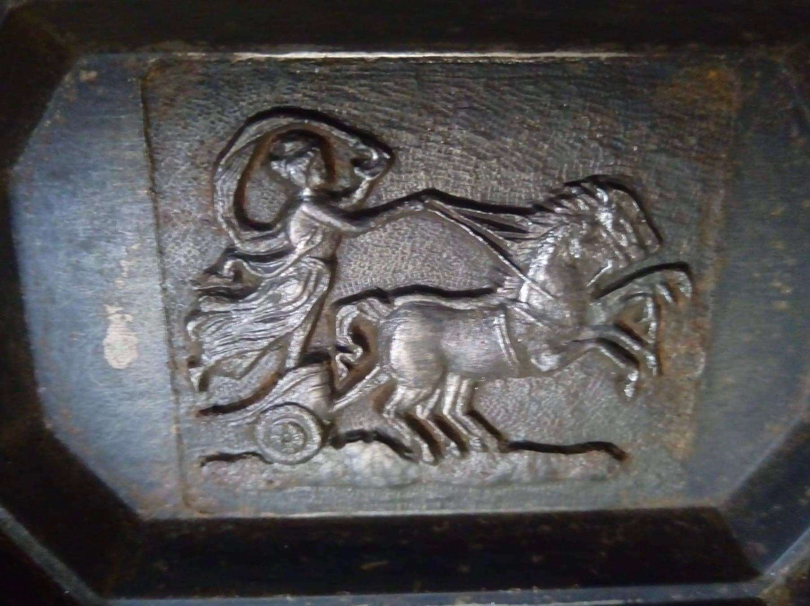

Game Time: Whoa! Bingo was a HUGE success in 2021 so we are offering it again! If you think you would like to participate, be prepared with a small-wrapped gift of yellow vaseline glass with a value around $25. Bring a gift with you or shop for something in your room-to-room travels. Check the agenda in the packet you receive on arrival for details. Observers are always welcome too!

Fun! The true measure of success of any convention is how much you enjoyed yourself. YOU are the key ingredient in making this happen! Join us as we celebrate our 23rd Annual Convention of friends, fun, food, and vaseline glass!

Cancellation Policy: In the unfortunate event that you must cancel, please notify us by September 9, 2022. Funds will be returned less a $15 processing fee. Any cancellations after September 9, 2022, will be forfeited to VGCI as a tax-deductible contribution.

Transportation: The area is serviced by the James M. Cox Dayton International Airport (DAY). The hotel does not have a shuttle so taxi cabs and Uber will need to be utilized. If you are driving, parking is free at the hotel. If you are planning to rent a car, you might also check rates into the Cincinnati/Northern Kentucky International Airport (CVG) which is about an hour’s drive from our convention hotel in Miamisburg, Ohio.

Registration Fees: The cost of registration includes a light meal at our Thursday evening reception, dinners on Friday and Saturday and speakers. Don’t forget that up to two breakfasts each day are included in your room reservation. There is no reduction in the fee if you plan on attending only part of the convention. All fees are per person.

Early Bird Registration Fees: As you can imagine, due to the rising costs of everything, in order to maintain our usual convention offerings, we find it necessary to raise our convention fee to cover our costs. However, the good news is, to soften the blow, we are offering an early bird rate that is only slightly above last year’s cost. Thank you for your understanding.

We are anxious to see everyone!

Your dues are current through: __________

Please fill out and mail this page along with your check made payable to “VGCI” to our Club Treasurer, Tom Foozer, 5134 Deerview Park Drive, Cleves, OH, 45002.

Name(s) of member(s) attending: _______________________________________________________________

Address: _______________________________

City/State/Zip: ___________________ __________________

Phone: _______________________ E-mail address: ______________________________________________

EARLY BIRD REGISTRATION FEE $160 per person (Register by July 31, 2022)
Number of persons _________ x $160 = $______________

Registration Fee $175 per person (After July 31, 2022)
Number of persons _________ x $175 = $ _____________

Optional Motor Coach Trip Greentown, Albany Glass, and Dunkirk Museums (must be received with registration)
Number of persons _________ x $69 = $_______________

Mound Cold War Discovery Center Museum Tour with Dr. Robert Bowman (Transportation on your own)
Number of persons planning to attend (no cost) ______________

Convention Piece
Convention attendees (1 per member) ______ x $45 = $________
Non-attendees (1 per member) _______ x $55 = $_________ (includes shipping)

VGCI Membership Renewal (Check second page for your current dues information)
□ Single Membership ($25) □ Junior Membership (under 18) (FREE)
□ Single + Spouse or Significant Other ($30) □ Corporate Membership ($25)

Tax-Deductible Donation (optional)
$_________________

TOTAL AMOUNT ENCLOSED: $ ___________ (one check is okay)

Meals
If you eat vegetarian, vegan, keto, etc., let us know so we can work with the Chef to make appropriate meal choices.
□ Regular Meal(s) □ Special Diet ________________________________

Displays
If you are planning to set up a display, please indicate how much space you will need.
□ Full table □ 1/2 table □ 1/4 table □ I’m bringing a favorite piece for the Best Single Piece category

Please Help Us To Be Better Prepared: I/We will be participating in the Swap & Shop by selling glass from my/our room.
□ Yes □ No □ Maybe

